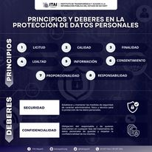

<https://www.facebook.com/photo.php?fbid=603324602009530&set=pb.100069959865896.-2207520000&type=3>

<https://www.facebook.com/photo.php?fbid=614275374247786&set=pb.100069959865896.-2207520000&type=3>

<https://www.facebook.com/photo.php?fbid=628801502795173&set=pb.100069959865896.-2207520000&type=3>